

LAKELAND SHS MATHEMATICS

MATHEMATICS METHODS
test 1 – Part a

NAME: ______________________________ Time allowed: 25 min

NON-CALCULATOR SECTION

1. Using the unit circle supplied [4 marks]
(a)
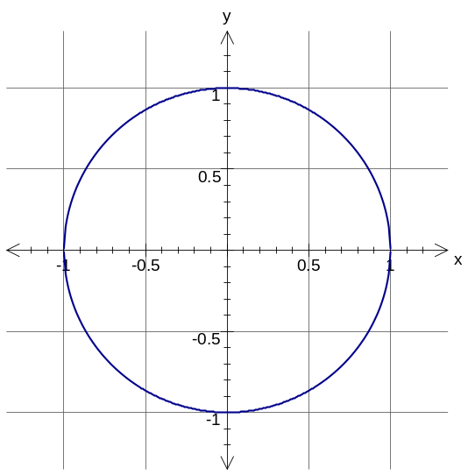
(i) find sin θ

sin θ = ____________

ii) draw the other angle with the same value as (i)
θ
(b)
(i) find cos θ

cos θ = ____________

ii) draw the other angle with the same value as (i)

α

2. Find the area of the triangle leaving your answer as an exact value. [3 marks]

4 cm
7 cm
60°

3. [5 marks]

- Convert these angles into degrees:

(i) 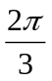

(ii) 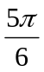

- Express these angles in radians

- 30º

- 210º

- State the exact value of sin (2π)

4. If f(x) = -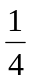x + 2 and g(x) = - 4x + 6 find: [5 marks]

a) f(4)

b) g(b + 2)

c) a if f(a) = 6

5. [6 marks]

State the domain and range for the following functions:
a) 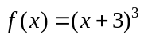 | b) | 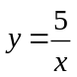
Domain: _________________________________ |  | Domain: _________________________________
Range: __________________________________ |  | Range: __________________________________

LAKELAND SHS MATHEMATICS

MATHEMATICS METHODS
test 1 – Part B

NAME: ______________________________ Time allowed: 55 min

CALCULATOR AND NOTES ALLOWED

- [3 marks]
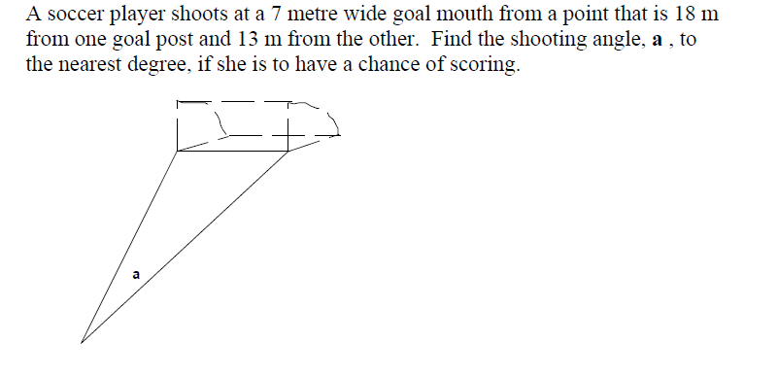

2. Find the value(s) of x in each of the following, giving your answer to 2 decimal places where appropriate. [3 + 4 = 7 marks]
(a)
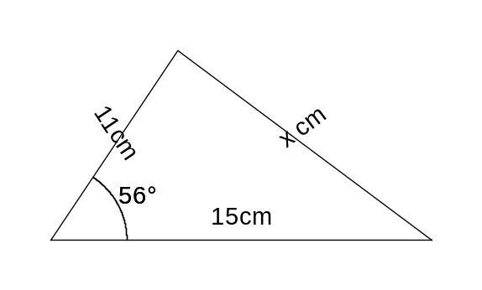

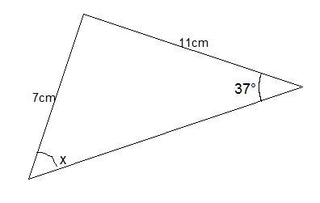
(b)

3. Determine the length of the side marked x for the triangle shown below. [6 marks]
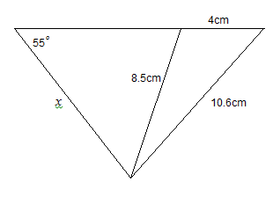

4.
Two people practicing their navigational skills notice a glider plane from their respective positions which are 850 metres apart on the same east-west line. From one location the glider plane is on a bearing of 035° and at an angle of elevation of 52°. From the second position the glider plane is on a bearing of 295°.

Determine the height of the glider plane above the ground. [ 5 marks]

5. [3 marks]

A minor arc of length 5.8cm is formed by an angle of 2.5 radians at the centre of the circle. Calculate the radius of this circle correct to 1 decimal place.

6. [3 marks]
Find the area of the shaded shape below if the radius of the circle is 15 cm and angle a = 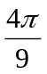radians. Give your answer in exact form.
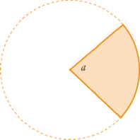

6. Find the area of the coloured shape below if the radius of the circle is 10 cm and angle θ is  radians. Give your answer to one decimal place. [3 marks]
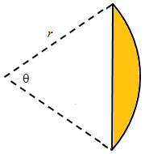

7. A segmental arch used in architecture has the following shape as seen in the diagram on the right. The curve of the arch is a circular arc with its centre being the intersection of the diagonals of the window. If the rectangular window measures 900mm wide and 1200mm high, calculate the area of the arch. [7 marks]

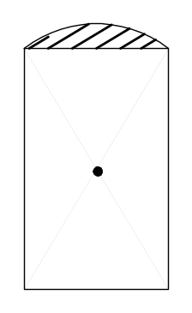

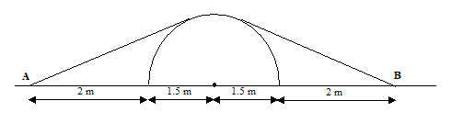
8.

If the radius of the dome is 1.5 m and the secured pegs A and B are 2 m from the outside edge of the flysheet, calculate the length of rope (to the nearest cm) needed to secure the shed to the ground. (Note that tangents make a right angle with a circle.)

Use radian measure and trigonometry to solve this. [7 marks]

